

UCN Computer Science

dmai0914

Group 5

First year project

Adrian Frunza Alex Muriuki Njogu Kristupas Sakalius

Monika Vyšniauskaitė Stefan Patatu

Hand in: 02-06-2015

# - Project Introduction -

This is the documentation file for the1st year project. Its purpose is to explain all the details of the software that has been produced along with the process of how it was made to give the basic idea of our way of thinking during the period of time we were making it.

We were working for a pharmaceuticals company named “Entafarma” and were asked to design a software which would be more efficient than the one they had before. The software should be able to provide information about every single product available, show statistics, work faster than its ancestor, have a stable database and most importantly handle all the sales automatically instead of having workers to do it manually.

The use of computers for daily tasks has rapidly increased over the past years. This technological advancement has brought about change; positive and negative. However, modern day businesses and companies are taking advantage of this change by digitizing their workflow(s) in order to lower production cost and generate more revenue and profit. Hence, implementation of management systems. Management improves the workflow. Management provides the sophistication and specification needed to perform certain tasks. Therefore, management systems should be of paramount importance to any successful modern day business or company.

# - Business Introduction –

## Problem / Problem area

Managing a pharmaceutical store can be quite the task especially if the reports are filed on paper. It becomes hard and tedious to keep track of specifics like drug quantity, expiry date, prices, stocks, orders and reports. The primary aim is to design and implement an easy to use system that can manage most pharmaceutical store activities. For example, a pharmacist selling drugs would probably like a system that is capable of certain tasks e.g. they can view the type and number of drugs in stock. They can update the stock of the drugs and pharmaceutical material. They can view orders. They can generate reports for better business analysis. The system can allow the pharmacist to quickly get digital information about a specific drug e.g. location of the drug in the store, date of purchase, expiry date, type of drug etc. The system also decreases the workload of the pharmacist(s) as they can carry out most tasks straight from the management system on their computer(s). Making it possible for the pharmacist to attend to more customers in a shorter period. This translates to efficient customer service and growth of loyal customers.

## Problem Statement

How can you automate and manage the entire workflow of a business or company, while taking into account customer satisfaction and product quality all at the same time?

## Method / Development procedure

• Qualitative interview to understand desired system functionalities and capabilities.  
• Study or analyse current system in use.   
• Business analysis and financial analysis.   
• Unified Process and SCRUM.   
• Eclipse for implementation of the store’s management system and testing for quality assurance

• SQL Management Studio for the store’s database.  
• Course books and reading material e.g. Applying UML and Patterns by Craig Larman.

# - Preliminary Investigation -

## Presentation of the Company

**The Company**

The decision to establish a pharmaceutical services company was made 22 years ago, Entafarma was founded in 1993 by Tauras Endriukaitis. At first, there were only 3 enthusiasts in the newly established company, whereas today their team consists of over 80(82 to be exact) employees – excellent specialists of their field. Among them, there are even 10 pharmaceutical specialists.

In the pharmaceuticals department the main power is split between a few people of their representative fields: Founder, who overlooks everything, Executive director is responsible for whole sales, he works with the pharmacies, Head of development is responsible for supplements(additives) and pharmaceuticals business in Baltic countries and finally Marketing manager who is responsible for sales of pharmaceuticals.

**Products / Services**

Entafarma offers four services: Logistics and warehousing, pharmaceutical marketing, wholesale of pharmaceuticals, repackaging of medicinal products. When it comes to pharmaceuticals, at the current moment company offers over 540 different ones. They have partners all over the world from which they buy their products to stock up. Then they sell the products to private pharmacies or their representative companies. Entafarma always provides delivery of the products on their part whether they deliver the products themselves or hire someone to do so. They also provide discounts/bonuses to particular customers that have spent a specific amount of money in their company or just put a discount for every product for everyone.

**Customers / Partners**

Company works directly with the majority of producers existing in the Lithuanian market; they have over 700 clients all over Lithuania, also in Latvia and Estonia. In 2004, their agencies in Latvia and Estonia were opened; in 2005, they celebrated the opening of the new, one of the most modern divisions of storage and logistics of pharmaceutical products in Lithuania. This company gets their products from all over Europe and even Canada. They work with UK, Austria, Check Republic, Hungary and previously mentioned Canada.

## Organisational Structure and Evaluation

## Structure

Entafarma was founded in Lithuania by Tauras Endriukaitis and two other people in 1993. He has been the C.E.O of Entafarma for the past twenty-two years. Next in line in terms of decision making is the executive director, the head of development and the marketing manager. Decision making is centralized amongst the four of them but the C.E.O. has to be informed about proposed decisions and he has the final say.

The company started out with three enthusiasts and currently has eighty two employees at its head office. The employees are grouped into four categories: logistics, pharmaceuticals marketing, wholesale pharmaceuticals and repackaging of medicinal products.

The company’s structure resembles Mintzberg’s The Machine Organisation (Bureaucracy). This is because machine organization is defined by its standardisation. The work at Entafarma is very formalized and there are many routines and procedures to be followed e.g. process of selling wholesale and retail to public and private pharmacies. [Ian Brooks, “Organisational Behaviour, 4th Edition”, p. 212-213]

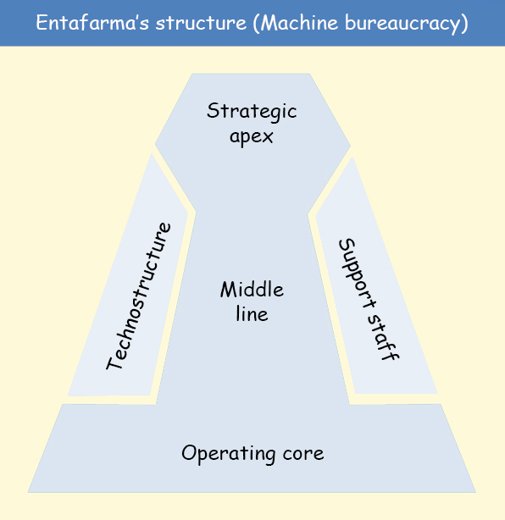

The tasks are grouped by functional departments. Each department and its head have a specific task that is assigned to them. For example, the head of the department of development is responsible of acquiring products from the supplier; the marketing manager is responsible for sales and there are I.T. employees who update the business data into the current system.

The company is an established organisation since it was established in 1993 and has expanded its markets in Lithuania, Latvia and Estonia. They sell their products all over Baltic countries.

Machine bureaucracy is based on performance organisations and not problem solving ones – they know what they have to do and their main concern is to get the best products and sell them. This is clearly evident in Entafarma.

One may reason that Entafarma’s organisational structure can also fall under the Professional Bureaucracy category. This is not the case. Entafarma’s decision making is centralized while in a Professional Bureaucracy structure the decision making is decentralized due to the presence of highly trained employees in a business – the manager or director can overlook everything. [Ian Brooks, “Organisational Behaviour, 4th Edition”, p. 213]

## Evaluation and Problems

While analyzing the Machine bureaucracy of this company, advantages and disadvantages have been discovered.

The first advantage of this structure is that there is no need for highly trained employees because of the repetitive tasks and work. The managers know exactly what they have to do and what they expect from all the employees. The workers are not given “problem solving” tasks, so they don’t have to manage big problems. For example, the IT people are responsible for updating the system with the data of the sales.

Another advantage is that the C.E.O. and the managers can overview everything in their company, allowing them to increase the overall quality of their services. Also, if an employee is not doing his work properly, the managers can check up on him to see what the problem is.

However, the disadvantage is that if a problem comes up, the employees can’t solve it themselves. They have to bring it to the managers first. The managers then might have to pass it even higher in the chain of management, resulting into a slow workflow until the problem is resolved by the management.

In addition to disadvantages, in this type of structure there are high chances of micromanaging employees due to tight schedules and deadlines. The employees may feel pushed around to do repetitive tasks without being fully in charge of those tasks. This de-motivates the employees causing poor performance, dissatisfaction and decrease in revenue.

Also, they will confront big changes in society. Because this kind of bureaucracy is perfect for companies that are “static”, every change will cause difficulties because of their standardized schedule. [<http://www.lindsay-sherwin.co.uk/guide_managing_change/html_change_strategy/07_mintzberg.htm>].

Overall, the Machine bureaucracy structure fits the company’s needs thanks to its standardization and methodical work. It is important that all the decisions must go to the superiors because people are working with medicines.  As a result, the Machine bureaucracy’s weaknesses are used as strengths here.

## Management

Entafarma’s organisational structure resembles Role Culture. There is a high level of bureaucracy and formality within the organisation. [Ian Brooks, “Organisational Behaviour, 4th Edition”, p. 267] The company has three senior managers: an executive director, a head of development and a marketing manager. They control and coordinate their own departments, but most of the decisions have to be approved by the C.E.O. Rules, procedures and job descriptions are clearly defined and closely followed by everybody in the company. Work is rationally allocated to employees according to their departments, job descriptions and skills.

The company has been active in the field since 1993. Over the 22 years of its existence, it has continuously expanded and improved. As a result, the business is well established and has created a stable environment for its employees. Thus the Role Organisational Culture embraced by the company is providing security and predictability for the staff, being the most suited for Entafarma.

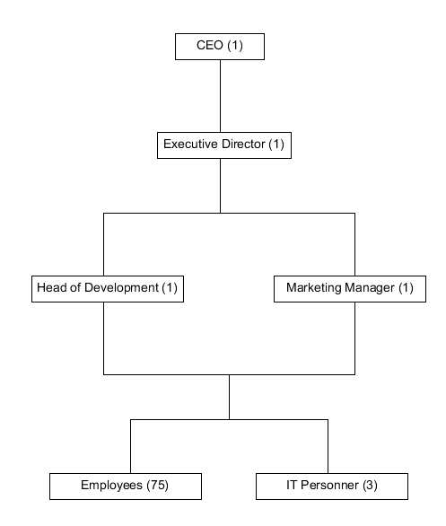

## Mission and Vision

**Vision** [Wendy Bloisi, “Management and Organisational Behaviour”, p. 76-77] [http://entafarma.lt/en/about-us]

“*Basics of Justice: To harm no one and benefit the society.*” - Cicero

**Mission** [Wendy Bloisi, “Management and Organisational Behaviour”, p. 76] [http://entafarma.lt/en/about-us]

*To develop services according to the tendencies and needs of the market, to build-up complex services, reliable partners, qualified and loyal collective.*

SWOT Analysis  
  
This diagram shows the strength and desirable future for the business. On the left side there are internal strengths, external opportunities and on the right are the internal weaknesses and external threats. [Wendy Bloisi, “Management and Organisational Behaviour”, p. 87, 111] [Erik Krogager, Jette Lauritzen, “Management accounting, financial measurement and planning”, p. 35-36]

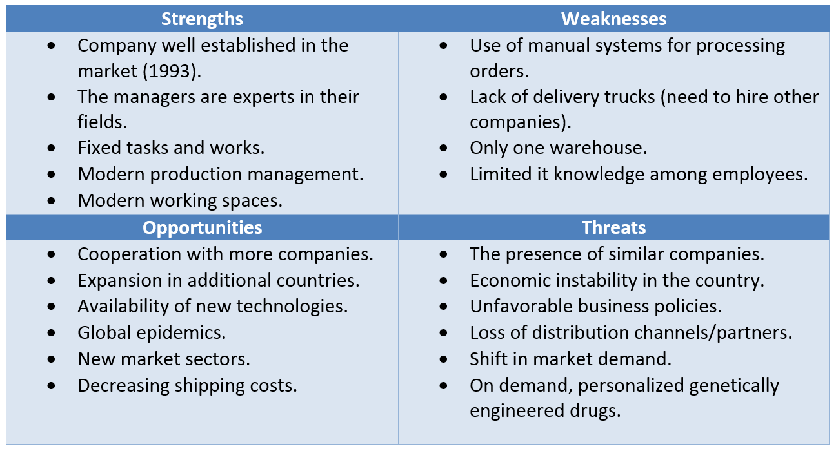

This SWOT Analysis is related to the company’s current financial position and strategic goals as it is evident that the company has funds to implement things like expansion into Baltic countries and enter new market sectors.

## Stakeholder Analysis

Below is a stakeholder analysis grid for Entafarma. It indicates the goals, likely behaviours, reactions and future actions of the company’s stakeholders in regards to the new system. [Wendy Bloisi, “Management and Organisational Behaviour”, p. 98].

This analysis is used to depict ideas of how the stakeholders will react to the new system and how to implement and optimise the system to a suitable standard for all the stakeholders.

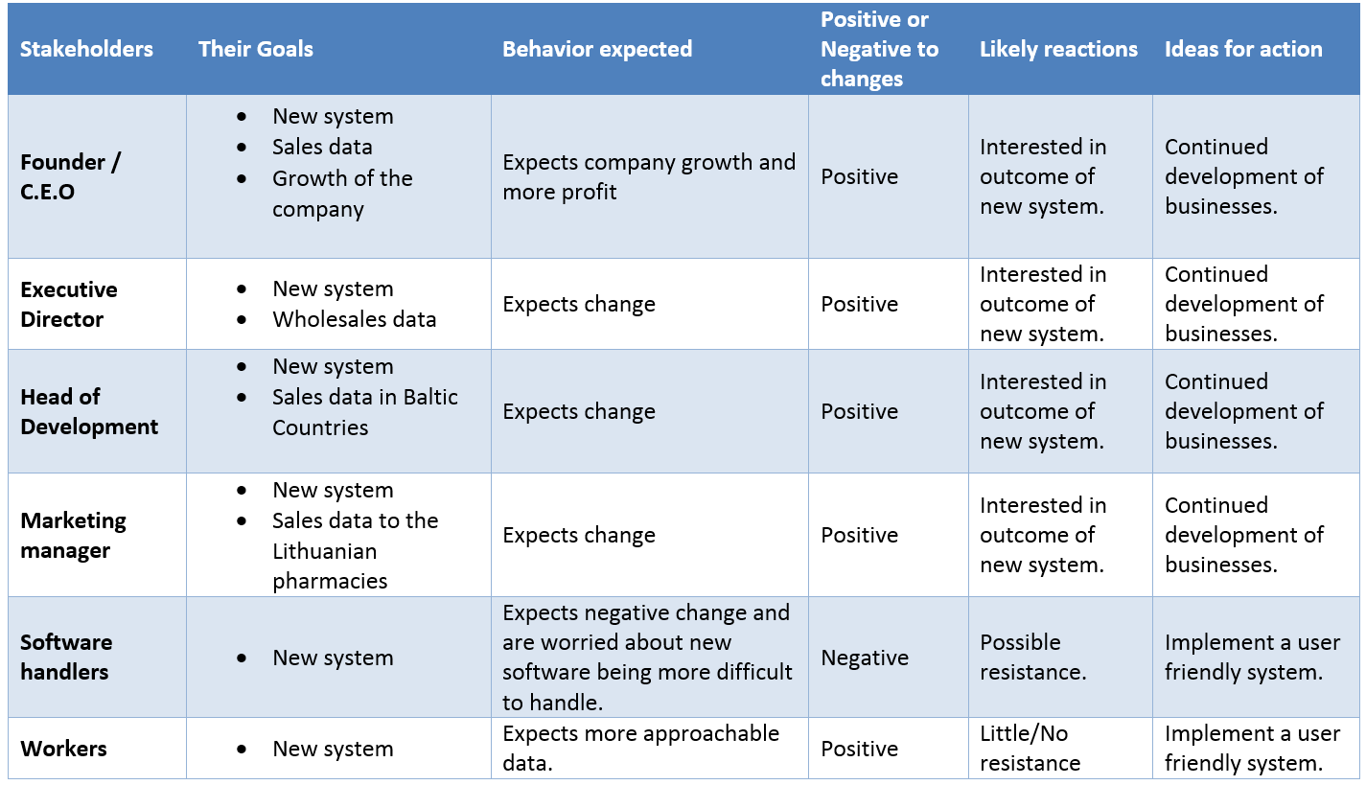

## Financial Position

Due to the company’s policy, access to Entafarma’s private balance sheet was not granted. The only financial statement available contains data in regards to sales made between the 52nd week of 2014 and 8th week of 2015 (10 weeks).

The data from the financial statement is visually represented in diagram below (number needed).

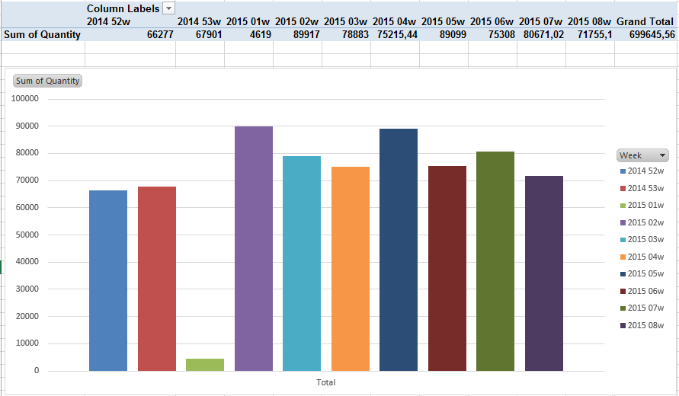

As seen in the above graph, the sales for the last 2 weeks of year 2014 are below the sales of every other week of the year 2015. The first week of 2015 is an exception. This indicates a bullish trend in Entafarma’s sales. Due to public holidays and people’s general preoccupation with the festivities, the sales were almost nonexistent. However, the week after, the sales hit a historical high in the history of the company as confirmed by the company’s CEO. [Erik Krogager, Jette Lauritzen, “Management accounting, financial measurement and planning”, p. 98-99]

This indicates that Entafarma’s financial situation is stable at the moment and  possibly in the near future presenting the company with opportunities like expansion into Baltic countries and diversification of services and products, as stated in the SWOT Analysis.

## Competitive Situation

Porter considers the business world as a competitive environment where the position of a company in the market is determined by five forces. Having a good understanding of where the power lies enables Entafarma to take advantage of its strengths and improve on its weaknesses.

[Erik Krogager, Jette Lauritzen, “Management accounting, financial measurement and planning”, p. 33-35] [Michael E. Porter, “Competitive Strategy: Techniques for Analyzing Industries and Competitors”, p. 4]

1. New entrants - the barriers of entry into Entafarma’s market are extremely high. The huge costs associated with setting up a company in the pharmaceutical industry  together with the strict laws imposed by the government in this field, renders the threat of new entrants almost inexistent. Also, for a new company to get all the necessary paperwork, combined with the knowledge required to do so, raises another barrier of entry. Thus giving Entafarma a favourable position.
2. Substitute products or services - DNA sequencing cost has continuously decreased, outpacing Moore’s Law beginning in January 2008. The cost per genome has gone down from $100M in 2001 to ~$5K in 2014 [<https://www.genome.gov/sequencingcosts/>]. In the following years it is expected that backward-looking medicine will be replaced by forward-looking medicine. Today, a person gets sick and goes to a doctor for treatment. Tomorrow, people’s DNA will be analyzed and any genetic vulnerabilities will be flagged, allowing doctors to give patients personalized medications based on that person’s DNA, not to treat them, but to prevent the appearance of a disease anticipated by the DNA test [<http://www.businessinsider.com/super-cheap-genome-sequencing-by-2020-2014-10>]. This will completely change the pharmaceutical market. The companies basing their businesses on selling traditional drugs, including Entafarma, will find themselves out of business.
3. Suppliers - Entafarma has 5 main suppliers based in separate countries, continents and operating under different laws. With such a range of suppliers, the company has a number of  choices when buying a product. The suppliers are fighting for doing business with Entafarma, allowing it to buy at low prices and within good conditions. Because of this, suppliers do not have much power and control over Entafarma.
4. Buyers -. Entafarma has contracts with approximately 1400 pharmacies from Lithuania, 6 wholesalers and approximately 900 doctors. The contracts are usually made for an entire year, making it hard for customers to switch from Entafarma to another supplier. On top of that, customers get discounts based on the total amount of money spent on the company’s products and services. This creates a huge advantage to keep doing business with Entafarma rather than switching over to another competitor.
5. Competitive background - Entafarma is the top 2 pharmaceutical company in Lithuania. Their main competitors are Sirowa, Orkla, Valentis and Walmark. Orkla is currently the only company surpassing Entafarma in terms of business. Even though Entafarma and Orkla are very similar in their offerings, Orkla is considered to be the leader in the market. This is due to their focus on advertising. Most of Entafarma’s customers have been with the company for a number of years, making them loyal and valuable. The company is basing its business on already existing customers, giving them discounts and helping them grow, thus allowing entafarma to grow along.

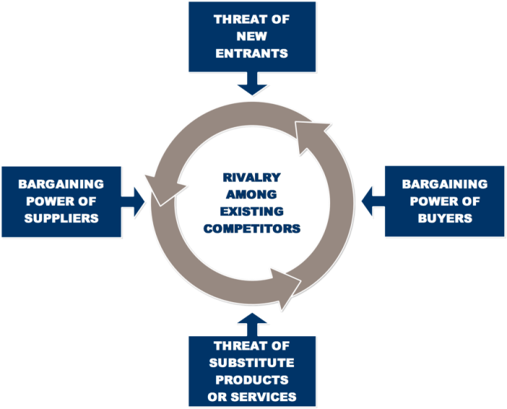

## Logistics, Supply Chain and Value Chain

Entafarma has 5 main providers: Pinewood, Lepicol, Vitabiotics, Zentiva Aloe and Beres.

The company places a huge order to its suppliers, thus guaranteeing them a discounted price. The order is then shipped to Entafarma warehouse (number needed). At the warehouse the products are transferred to their respective shelves and stored under the right conditions of temperature and humidity. [Dave Chaffey, “E-Business and E-Commerce Management: Strategy, Implementation and Practice”, p. 335-348]

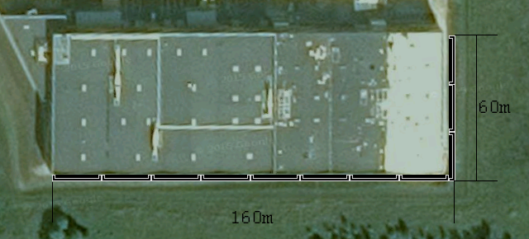

Some of the products go through an extra step of repackaging. Old labels are removed and equivalent translations are added, according to the language of the countries they are going to ship the products to. [Dave Chaffey, “E-Business and E-Commerce Management: Strategy, Implementation and Practice”, p. 348-353]

When the product is ready for delivery, it is assigned a price.

In the last step the products go from the warehouse to the customers. Entafarma has contracts with a range of shipping companies. When an order is made, the products are packaged and prepared for delivery. The shipping company ensures that the drugs are transported in proper condition and that they reach the customer undamaged.

The payment is received according to the contract in place. Usually, customers pay on a 30-day basis, while some of them pay for each order before or after its delivery.

## E-business and E-business Strategy

E-business is the conduct of business processes on the Internet. Most companies take advantage of the continuously growing online environment to increase their business. By establishing an online presence through social media, online advertising, online shops, enterprises seek to increase brand awareness, attract more customers and expand into new areas. [Dave Chaffey, “E-Business and E-Commerce Management: Strategy, Implementation and Practice”]

Entafarma has established an online presence through their website  (<http://entafarma.lt/>). In 1998 the company acquired the domain with the same name. The website has been online ever since. [Dave Chaffey, “E-Business and E-Commerce Management: Strategy, Implementation and Practice”, p. 78-79]

Even though Entafarma is mostly taking orders over the phone, the website is an important part of their business. The website features general information and contact information about the company and helps increases trust among prospective customers.

Available both in English and Lithuanian, the content on the website is easily understood by the majority of the targeted customers.

Email is another part of Entafarma’s online strategy. Customers can order products, as well as receive support or request more information through email. [Dave Chaffey, “E-Business and E-Commerce Management: Strategy, Implementation and Practice”, p. 131-132]

Due to the “Machine Bureaucracy” strategy, a complete e-business innovation, would bring with it big changes in the company. This can lead to slow progress in the beginning due to the strict protocols and rules.

For the near future, the company has no plans for developing an online shop. Because of it’s B2B model, customers acquisition is done directly and contracts with other businesses are signed years in advance. This makes the existence of an online shop not useful at the moment.

## Strategic Goals

The strategic goals outlined here are to be achieved by implementing this proposed software system. They are closely related to the company’s long-term mission. [Wendy Bloisi, “Management and Organisational Behaviour”, p. 74-75]

1. Reduce the time needed by warehouse operators to handle the orders.
2. Expansion into new countries.
3. Increase the number of orders that can be handled in a short timeframe.
4. Increase customer retention.
5. Increase the quality of services.
6. Generate meaningful statistics.
7. Develop and use a customer database.

## Business Case

### Introduction

In order to remain competitive in the pharmaceuticals market, Entafarma needs to stay ahead of competition. An improved IT system is required to optimize workflow across departments, reduce costs and offer a better overview of current operations. [Schmidt, Marty J, “The Business Case Guide, 2nd Edition”]

### Management Summary

Currently, everything is done manually. The only use of IT is once a month, when the IT department inputs the sales from the previous month into a spreadsheet. The process is slow and inefficient.

To solve this issue, the following options were considered but not chosen:

1. Hire more people to make the current bookkeeping process faster and to manually generate useful data for the executives. This option is not recommended because it involves high costs. On top of that, it is not scalable.
2. Give all employees access to current database. This is not recommended because it requires a computer for every employee and it raises security problems. Also, all the employees would be required to learn to use the system.
3. Buy an IT system. Not chosen because it would not be fully compatible with the company’s needs and structure.

It has been concluded that a new, custom-made IT system is the best option. It will improve workflow across all departments, reduce costs, provide live info of the current sales situation and allow for better scalability.

### Benefits and Costs

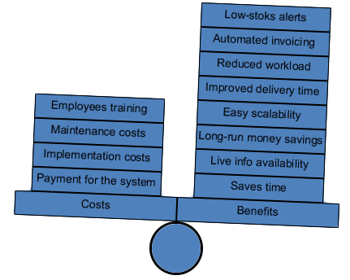

[Boardman, Anthony E, Greenberg, David H, Vining, Aidan R and Weimer, David L, “Cost–Benefit Analysis: Concepts and Practice, 2nd Edition”]

### Impacts and R2isks

The change to a new IT system poses a number of risks. The negative impact generated by the time needed for the staff to learn the system is only short-term. After the end of the adjustment period, the negative impact will no longer exist. This risk can not be avoided but its effects can be reduced. By offering training to the staff, the adoption time can be significantly reduced.

### Conclusion

Because of all the reasons enlisted above, it is highly recommended for Entafarma to invest into the proposed IT system. It will definitely benefit the company in the long-run, as well as offer significant advantages starting from its adoption.

# - Work Flow –

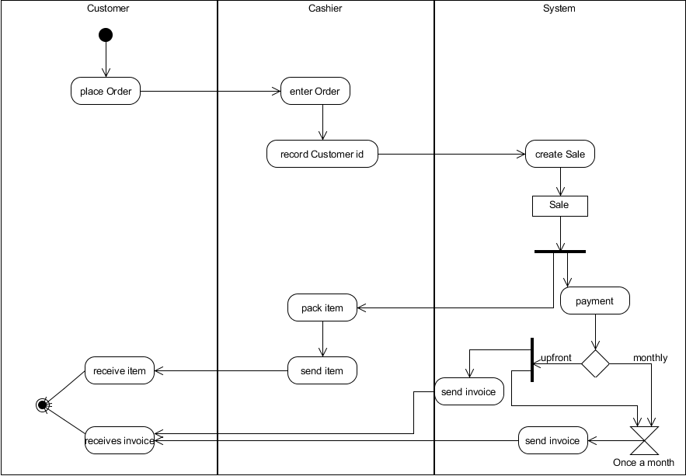

The workflow starts with a customer placing an order over the phone. Cashier then starts a new order and types in the customers identification. If the customer is found in the system, the sale is created and items are packed and sent tot the customer.

What concerns payment, there are two types of it. The customer can either pay upfront and receive an invoice at the time or pay for the all the things bought at the end of the month. He then would be sent an invoice to be reminded of it and to know how much exactly he has to pay.

Customers who have bought upfront also receive an invoice at the end of the month but theirs say that they have to pay nothing for this month.

# - Domain Model -

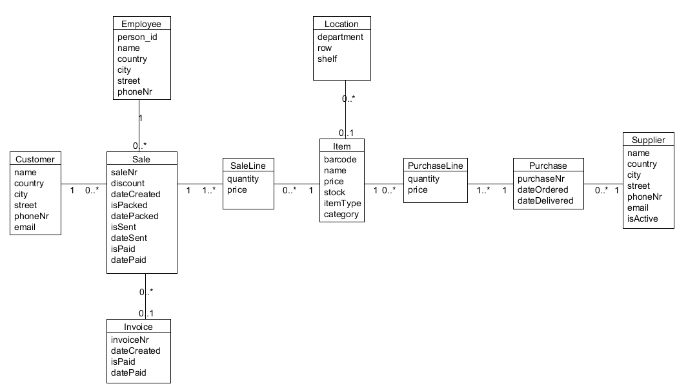

In Employee there is a person_id which represents a personal identification number which each person in Lithuania has. It is similar to Denmark’s cpr number, however, there it is called Personal Code.

The Customer has no such field because Entafarma deals mostly with other companies. However, there are a few private pharmacies which don’t constitute as such so the class name is Customer. Both of these clients are not people so their names are unique and can serve as identifiers within the system.

In the Sale class there is an attribute called discount. It is used to give customers who have spent a certain amount of money at Entafarma, a discount. The other fields in the Sale class, besides the saleNr, are set to null on the creation and only when the actions attributed to them are made, these fields are updated by a worker.

Multiplicity between Sale and Invoice is zero to one because the sale is created first and only then the invoice.

SaleLine contains the quantity of items and the price of one. This is required to know at what price the products were sold since the amount in the Item class can be changed a couple of times through the year.

Items have a unique identifier barcode. They also have stock to know when there’s a need to resupply. itemType is to show whether the item is liquid or pills while category describes the purpose of the medicine - vitamins, antibiotics, etc.

The company has one huge warehouse so there’s a need for Location class to find everything without wasting time searching every time. To make this as efficient as possible the company made it that on one shelf, only one type of items are stored even if it isn’t filled up. However, if there are more items of the same type than the shelf can hold, they are reserved another one. This is shown in the multiplicity.

PurchaseLine is similar to SaleLine. However, PurchaseLine is for buying items instead of selling them.

Purchase has the dates of when the order was placed and when received to be able to tell how quickly the items are delivered.

In the Suppliers there is a field called active. It can be TRUE or FALSE depending on whether the company still orders from that particular place or not.

# - Functional Requirements –

## Use Case Diagram

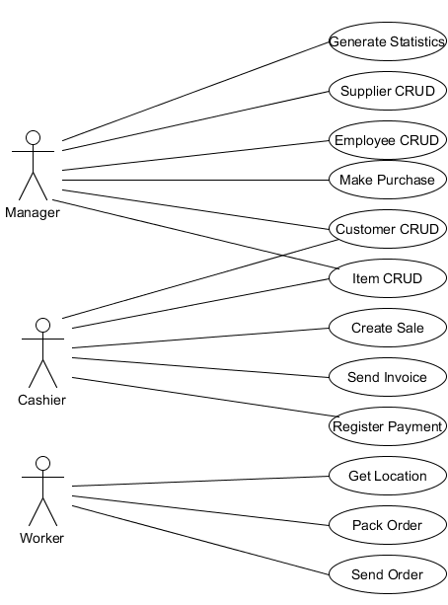

The system should handle three actors, who are seen as roles in the system.

The first one is the warehouse workers. They are able to get item locations to find them quickly and efficiently. Then mark when items are packed and loaded into a truck and sent.

The second one is the Cashier. Actors in this role are able to adjust information about items and customers, but their main priority lies in making sales and registering payments after they’re done at the end of the month. Send invoice use case is also connected to Cashier, however, they do not send it themselves. The system does it automatically and the actor can only find invoices to check on them or register payment.

The third and topmost one is the managers. They have access to generate statistics to gain information about profits and what is being sold. Also they can make purchases from suppliers when items are out of stock and edit information about suppliers, most often add or update whether they’re active or not. Furthermore managers can edit customer and item information along with cashiers.

## Use Case Brief Description

There are three main actors in the use case diagram; Manager, Cashier and Warehouse worker. Below are brief descriptions of the use cases as seen in the use case diagram.

Use Case: Generate statistics

The manager would like to generate and view statistics of the business. He/she then checks the system to view information such as number of orders made, how many items were sold, how many items are in stock, customer and supplier information. The system displays this information.

Use Case: Supplier CRU

The manager identifies a supplier and makes an agreement with it (the company). Then he/she adds the information to the system and can view or update the supplier data e.g. name of the supplier.

Use Case: Employee CRU

The manager hires an employee. He/she then creates an employee object in the system and can view or update the employee information e.g. address.

Use Case: Make Purchase

The manager has identified an item he would like to buy from a supplier. He/she checks if the supplier exists in the system and if so orders the desired item.

Use Case: Customer CRU

A customer calls or sends an e-mail to Entafarma. A contract is made between the two and a manager creates customer in the system. Then he can view or update its information e.g. name of the customer.

Use Case: Item CRU

Manager orders new items from a supplier. He/she then creates the item in the system before or as soon as it gets to the warehouse. He can also update information about the item if need be.

The cashier can read information about the item in the system.

Use Case: Create Sale

A customer calls or sends an e-mail to Entafarma to place an order. Cashier checks if customer is in the system and starts a sale by adding items. When all items are added he/she specifies the payment type (upfront or at the end of the month) and finishes the sale.

Use Case: Send Invoice

A cashier checks the system to see if an invoice was sent to a customer. If invoice was somehow not automatically sent, the cashier re-sends the invoice by clicking on “send invoice” button and sends the invoice.

Use Case: Register Payment

A customer pays for the sent invoice. Cashier finds that specific invoice and marks it as paid in the system.

Use Case: Get Location

Warehouse worker enters a sales number in the system and the system returns him item names with their locations in the warehouse.

Use Case: Pack Order:

Warehouse worker packs the items that he received locations for. When it is done he types in the sales number and marks it as packed.

Use Case: Send Order

Warehouse worker carries the packed items to the truck and once it leaves marks that the order is sent in the system

* As noted in the use case diagrams and brief description, “CRU” has been used instead of “CRUD.” This is because the delete function is not implemented for it would cause issues in the database. For example, it will not be needed to delete an employee from the system because it is connected to a sale. This means that if an employee is deleted, the sale will have an issue as there would no longer be a reference to the employee who made the sale.

## Prioritisation List

Out prioritization list consists of two criteria - complexity and business importance. The first one stands for how hard it is to implement a use case while the second its relevance to the company.

Both criteria have been ranked for maximum significance. The highest ranking is six and the lowest is one. The lower the rank, the more difficult or crucial the use case is. After these numbers are multiplied, the score derived decides the use case’s place in the prioritization list. If there are use cases with the same score, they are put in the order that is best for programming.

|  |  |  |  |
| --- | --- | --- | --- |
| Prioritisation List: | Complexity | Business Importance | Score |
| 1. Create Sale | 5 | 6 | 30 |
| 1. Register Payment/ Send Invoice | 4 | 5 | 20 |
| 1. Item CRUD | 2 | 5 | 10 |
| 1. Customer CRUD | 2 | 5 | 10 |
| 1. Employee CRUD | 2 | 5 | 10 |
| 1. Get Location | 5 | 2 | 10 |
| 1. Pack Order | 3 | 3 | 9 |
| 1. Send Order | 3 | 3 | 9 |
| 1. Purchase | 4 | 2 | 8 |
| 1. Suppliers CRUD | 3 | 2 | 6 |
| 1. Create Statistics | 6 | 1 | 6 |

## Create Sale Fully Dressed Use Case

|  |  |  |
| --- | --- | --- |
| Use case name | createSale | |
| Actors | Cashier | |
| Pre-conditions | Customer and Item(s) has to exist in the system, Employee is logged in | |
| Post-conditions | Sale is registered in the system | |
| Frequency | As many times as needed | |
| Main Success Scenario | 1. Cashier types in the customer’s name to start the sale. | 2. The system asks for an item’s barcode and quantity. |
|  | 3. Cashier types in the product’s name, quantity and the same attributes of all the products the customer wants to buy. | 4. The system shows the price of each product purchased and updates total amount. |
|  | 5. Cashier clicks that all items were added | 6. The system asks for the payment |
|  | 7. Cashier chooses the payment type | 8 The system shows that the sale has ended |
| Alternate Flows | 1a. The customer doesn’t exist in the system  3a. The product with that name doesn’t exist  3b. The product with that name is out of stock | |

In this diagram the process of making a sale is shown. First the customer is found by (company)name for it is unique. Then a pop up window appears where the employee types in item names and chooses the correct ones from the drop down list. All the sales are done through phone or by email so that is the information being provided by the customers. After that the cashier chooses the payment type (upfront or monthly), he/she finishes the sale.

## Create Sale System Sequence Diagram

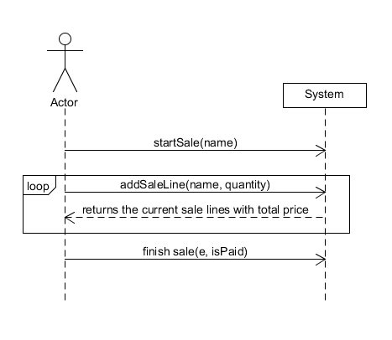

The use case consists of three methods. The first one starts the sale by inputting the customer’s (company’s name which is a unique identifier) to find the customer. If the client is found in the system, the second method starts.

Then an item is found by its name (the employee chooses the right one from the drop down list) and its quantity inserted. This is repeated until all the times have been added.

## The last method creates a sale object with all the information gained from the previous methods and the employee object and payment type (upfront or at the end of the month). Once this is done the sale object is passed to the database, then saleLines and the createSale method is finished.

Operation Contracts  
  
All three methods described above are explained are shown in the operation contracts below. They present what changes after each method and what associations the new sale receive.

Operation: startSale(name);

Use case: createSale;

Pre-condition: Employee is logged in, Customer exists in the system;

Post condition:

* Customer object c was created;
* c.name became name;

Operation: addSaleLine(name, quantity)

Use case: createSale;

Pre-condition: Item(s )has to exist in the system;

Post condition:

* SaleLine object sl was created;
* sl.name became name
* sl.quantity became quantity
* sl was added to an ArrayList<SaleLine>

Operation: finishSale( e, isPaid)

Use case: createSale;

Pre-condition: ArrayList<SaleLine> sls has to have been created, Employee e and Customer c hast to exist in the system.

Post condition:

* Employee object e was associated with employee
* A Sale object s was created;
* s.paid became paid
* s was associated with employee;
* s was associated with item;
* s was associated with customer;
* s was associated with an ArrayList<SaleLine> sls

## SaleGUI Progress

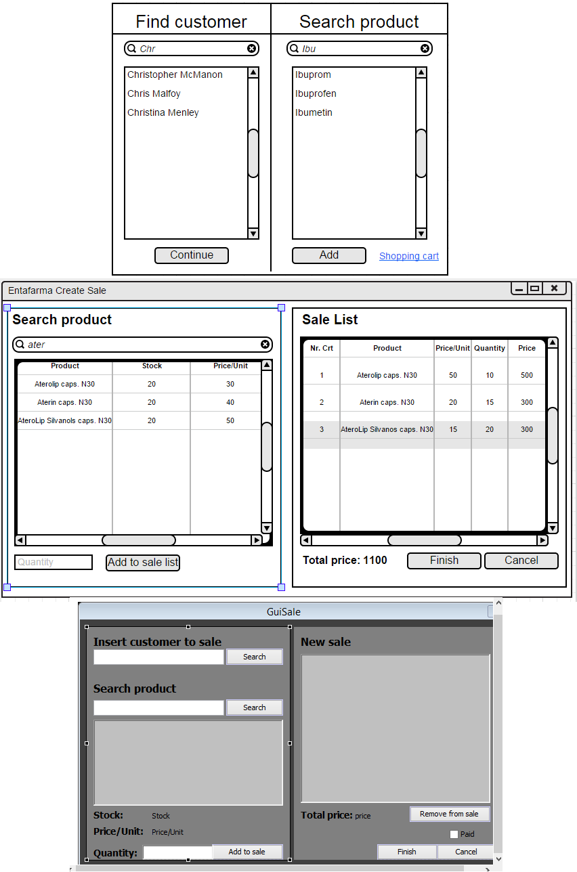

This was the first mock-up for the sale graphical user interface. Only the main and most important features were added thus it looks very lackluster. At that time it could only do two things: find the customer and add only one item at the time to the sale.

## 

The final version of sale graphical user interface. Understandable, functional, compact, easy to use and provides all the features needed.

After awhile, a few changes were made regarding the interface. A sale list was created so it would be possible to see what items were added. When searching for a product, user is able to see the stock and price of each item. In sale list the price per unit, quantity of products and total price is displayed.

## Quality Criteria

1. Robustness - the IT system should be able to handle multi users without complains, evading deadlocks. If a failure occurs, it should restart in less than a minute. Also it shouldn’t corrupt any data. (Changes made should be abandoned if the action wasn’t finished.)
2. Reliability - the percentage of uptime should be around 98%. If the server is not working, the system should try to reconnect every minute. (A local copy should be created so the data would be accessible even when the server is down.)
3. Ease of Use - employees should take no more than two hours to learn the new software. (Each type of employee (Warehouse worker, cashier and manage have different access to the system which makes their use much simpler and the user interface not overcrowded with unneeded information.)
4. Security - password protection for all three types of employees.

# - Risk Analysis -

Risk management is an important part of every project. If one does not consider possible problems, it becomes harder to deal with them when they appear. It can even fail the whole project.

In this particular case the main problems considered were estimation and communication. It is easy to say everyone gets along well, but that does not mean those people can work in a group. In a project of high importance it is easy for opinions to go in different directions and arguments to arise.

Also, for a newly formed group time management may become a huge obstacle. Without prior experience it is hard to say what problems will take most time and how much exactly. This then can push people off the designed schedule and leave the project half way finished by the deadline.

To prevent these things from happening, the risk analysis table was made. Possible problems were given points for how likely they were to arise and how much they would affect the project. After that they were prioritised by total number and ideas for solving them were created.

|  |  |  |  |  |
| --- | --- | --- | --- | --- |
| Risk | Probability (1-6) | Severity (1-6) | Total | Handling |
| Scope is ill defined | 5 | 6 | 30 | Extra interviews |
| Estimates are inaccurate | 5 | 5 | 25 | Have a second, pessimistic schedule and use that |
| Time management (gold plating inflates scope) | 4 | 6 | 24 | Stick to predefined time scope |
| Under communication | 4 | 5 | 20 | Constant repetition of most important facts |
| Requirements are incomplete | 4 | 4 | 16 | Continued communication with the customer |
| Poor coordination (jobs, extra projects) | 4 | 4 | 16 | Scheduled meetings |
| Lack of Management or Control | 3 | 4 | 12 | Stick to the plan |
| Requirement changes | 3 | 4 | 12 | Work in iterations/sprints |
| Number of users | 3 | 3 | 9 | Proof-of-concept |
| Users Reject the Prototype | 2 | 4 | 8 | Renew the design |
| Dropping out | 1 | 4 | 4 | Reduce the scope of the project |

Most of these issues were averted by prior knowledge about them. Those few that could not be avoided were solved using the provided ideas and others that were devised on the spot.

However, a lot of technical problems were not mentioned in the risks analysis. That was done on purpose for Unified Process (UP) is applied. By use of mock-ups and diagrams for most complex use cases it prevents a lot of issues from arising. Some of which are failing to understand customer needs or the software architecture to be used.

# - Process -

# - Design –

## Relational Model

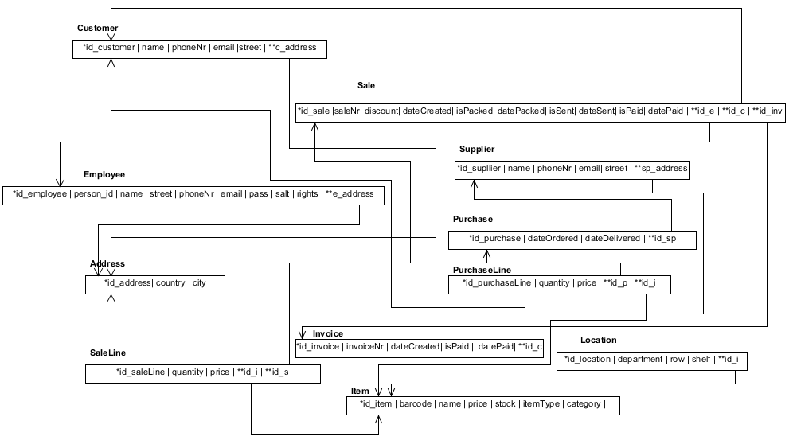

This is the relational model in regards of the connection to the database. It should be explained that quite a few attributes have their own respective id’s. The main reasoning behind that is that it makes making changes and updating everything way easier due to the fact that you do not have to edit the rest of the tables. It is way more efficient and practical this way.

## Interaction Diagram

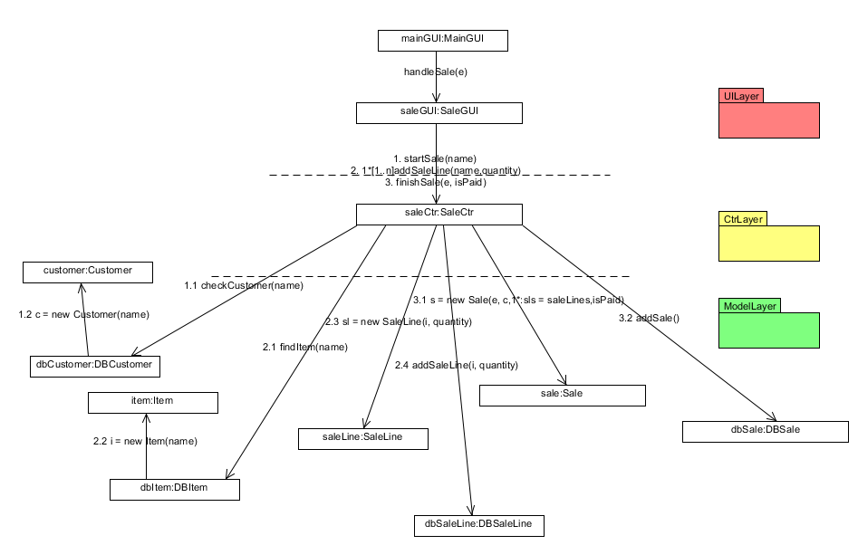

This is the communication diagram of create sale which models the interactions between objects in terms of sequenced messages. It represents a combination of information taken from Class, Seqyence and Use Case diagrams describing both the static structure and dynamic behavior of our system.

## Design Class Diagram

[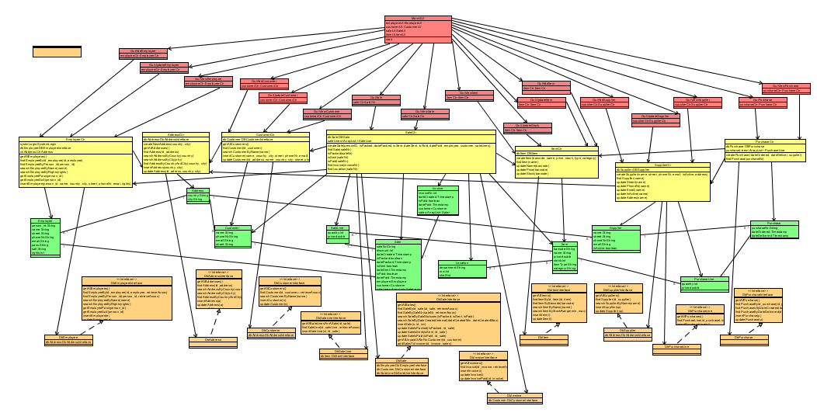](http://i.gyazo.com/39b40d3bbd0aadd3052f672583b575bc.png)

**( CTRL + Click on picture for full size [HyperLink] )**

The diagram here shows the way the system is implemented or how it was planned to be made. However, it is too large to fit well within the page so it is only possible to see the program’s outline but not the methods, attributes or their types.